WEEK 6 PROJECT REPORT

PRODUCT REVIEW AND RATING MANAGEMENT SYSTEM
Student Name: Maria Jency
Course: Bachelor of Computer Applications (BCA)
Project: E-Commerce Database Management
Week: 6
Database: ecommerceD__B
Technology: MySQL

1. Abstract
The Product Review and Rating Management System is developed to collect and manage customer feedback about products in an e-commerce database. Customers can provide ratings and comments about products. The system stores reviews and helps analyze product performance using SQL queries.

2. Aim
To develop a Product Review and Rating Management System connected with the existing Customer and Product tables and analyze customer feedback using SQL.

3. Objectives
- Create a Review table.
- Establish relationships between Customer, Product, and Review tables.
- Store customer reviews and ratings.
- Retrieve product review details.
- Calculate average product ratings.
- Identify highly rated products.
- Generate customer feedback reports.

4. Database Design
The project uses the existing ecommerceD__B database.
The Review table contains the following attributes:
Attribute | Description
Review_ID | Unique review identifier
Customer_ID | Customer reference
Product_ID | Product reference
Rating | Product rating from 1 to 5
Review_Text | Customer comments
Review_Date | Date of review

5. Table Relationships
Customer – Review Relationship: One customer can write multiple reviews, and each review belongs to one customer.
Product – Review Relationship: One product can have multiple reviews, and each review belongs to one product.

6. Constraints Applied
- PRIMARY KEY – Identifies each review uniquely.
- FOREIGN KEY – Connects reviews with Customer and Product tables.
- NOT NULL – Ensures Rating and Review_Date are provided.
- CHECK – Ensures ratings are between 1 and 5.

7. Implementation
A Review table was created in the existing e-commerce database. Customer_ID and Product_ID were connected to their respective tables using foreign keys.
SQL INSERT statements were used to store customer feedback and product ratings. SELECT statements were used to retrieve review details. JOIN operations were used to display customer and product information along with reviews.
Aggregate functions such as AVG() and COUNT() were used to calculate average ratings and the number of reviews for each product. GROUP BY and ORDER BY were used to organize the rating analysis.

8. Reports Generated
- Product Review Details: Displays product reviews and ratings.
- Customer Review History: Displays customer names and their reviews.
- Average Product Rating: Calculates the average rating for each product.
- Most Reviewed Products: Identifies products with the highest number of reviews.
- Highly Rated Products: Identifies products with high average ratings.
- Rating Distribution: Analyzes the number of 5-star, 4-star, and low ratings.

9. Result and Output
The SQL queries are designed to store customer feedback and generate product rating reports.
Screenshot 1: Review table structure.
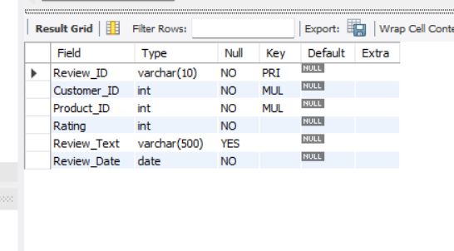
Screenshot 2: Inserted review records.

Screenshot 3: Product review details.
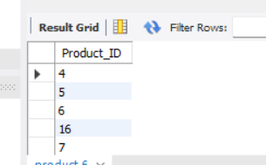
Screenshot 4: Customer review history.
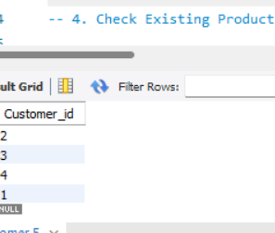
Screenshot 5: Average product rating report.

Screenshot 6: Highly rated products report.


10. Conclusion
The Week 6 project demonstrates how SQL can be used to manage customer reviews and product ratings in an e-commerce database. It provides practical knowledge of table creation, constraints, foreign keys, JOIN operations, and aggregate functions. The generated reports help understand customer feedback and product performance.

11. Future Enhancement
The system can be extended with customer review verification, review moderation, rating-based product recommendations, and graphical rating dashboards.

